Credit Exchange Program in China

Contact People
- Ms. Chu, School of International Education, Huangshan University
- iec@hsu.edu.cn, 751127772@qq.com (Stan)
Purpose
- Learn Mandarin Chinese.
- Broaden your world view and cultural understanding.
- Develop valuable career skills.
- Travel the world and make new friends.
- Promote mutual understanding between the young people of the U.S. and China.
Eligibility
- Any European and American undergraduate student.
Dates
- Available to any of the months between March and June, between September and December. The duration of your stay also depends on your own. Staying for May and July every year is strongly recommended.
Language Requirement
- Previous knowledge of Chinese is not required.
- Beginning, intermediate, and advanced Chinese courses will be offered.
- Courses are taught by experienced teachers of Mandarin Chinese.
Classes
- Students will take 6-10 hours. The hours will consist of Chinese language and culture classes,
- A class taught in English on Chinese business etiquette and practices (business students).

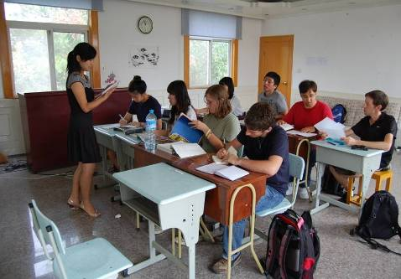
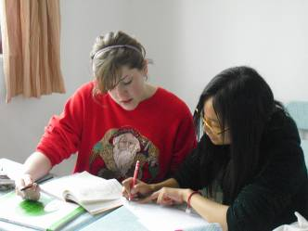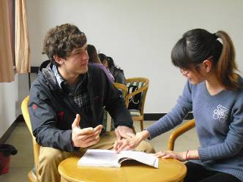
The curriculum includes both classes and individual tutoring

- Instead of Chinese language, students can also choose to attend to courses that are related to Hospitality Management, which is all taught in English, plus practices in a decent hotel at the same time.
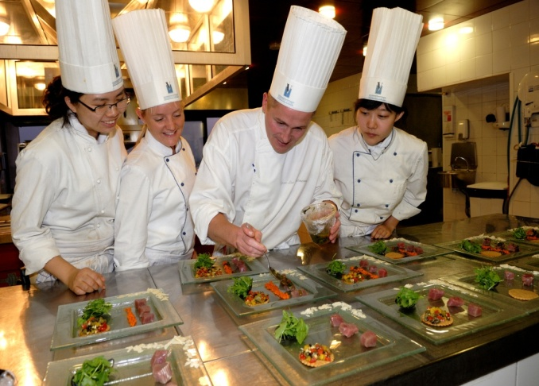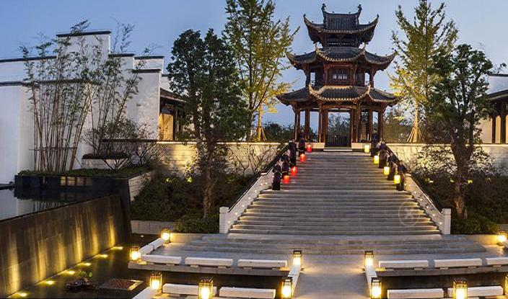
Preparation
- Dr. Debbie McAlister will help students prepare for their summer in China with regular meetings during the semester.
- Emily Tilton, and Anthony Barraza, two Southwestern College students, participated in this program at Huangshan University, and will be available to answer questions about the program from a student’s point of view.
The School
- Students will be living and studying on the campus of Huangshan University. The university has a student population of about 18,000 students.
- The campus is a gated community with security guards at the entrances.
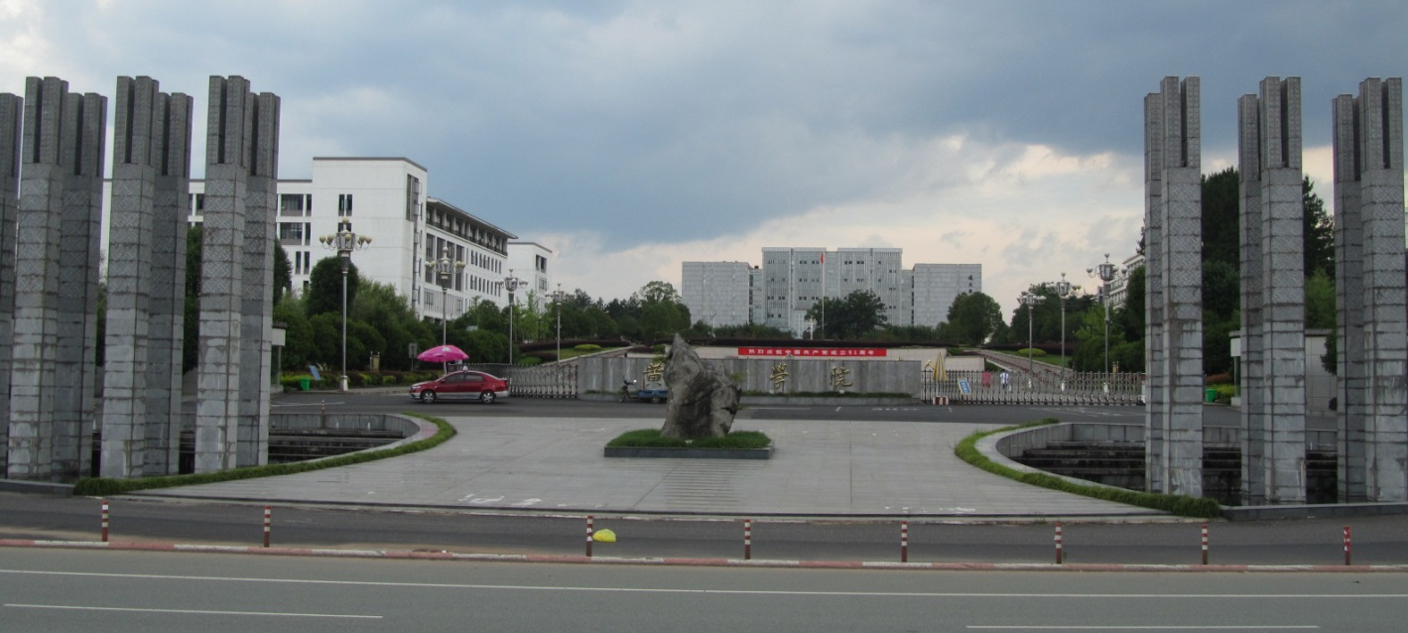
Main entrance to the South Campus of Huangshan University
The Dormitory
- Students will be living in the International Student Dormitory with other international students.
- The classrooms for the international students are located right opposite to the dormitory.
- Each dorm room has two single beds, two study desks, western style bathroom with shower, air conditioning, and Wi-Fi.
- Each floor of the dormitory has a full kitchen.
- Washing machines and dryers are available.
- The dorm has a house mother who screens the people entering the dorm and locks the front doors at night.
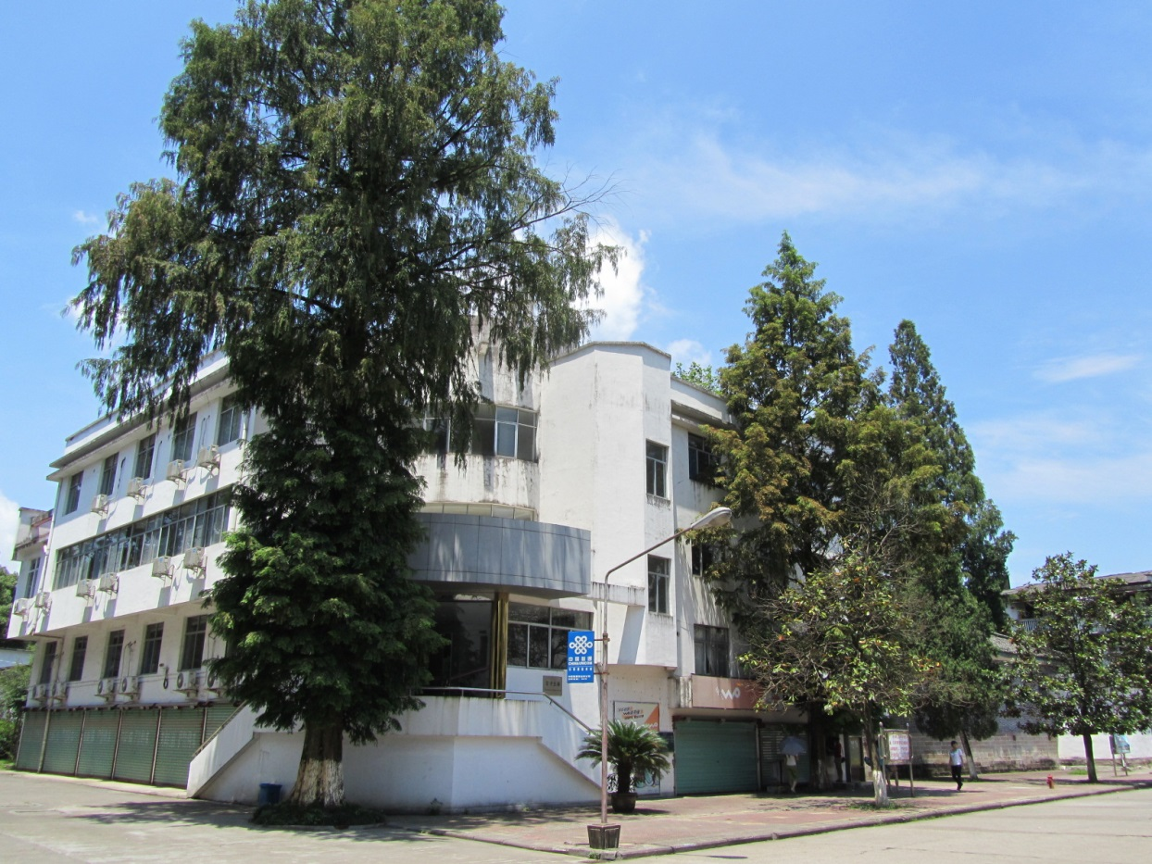
International Student Dormitory on the North Campus of Huangshan University
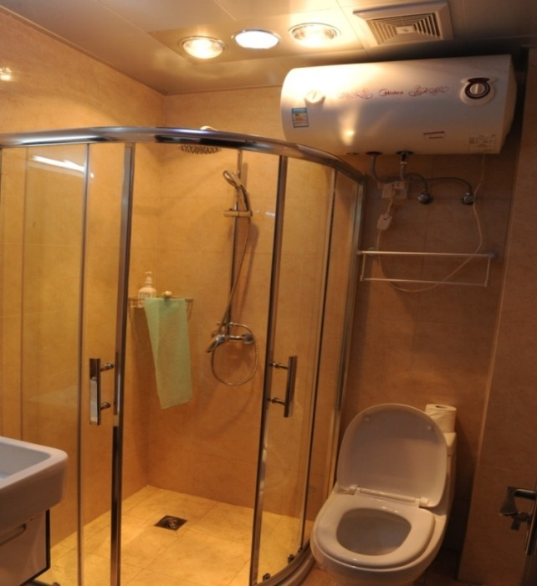
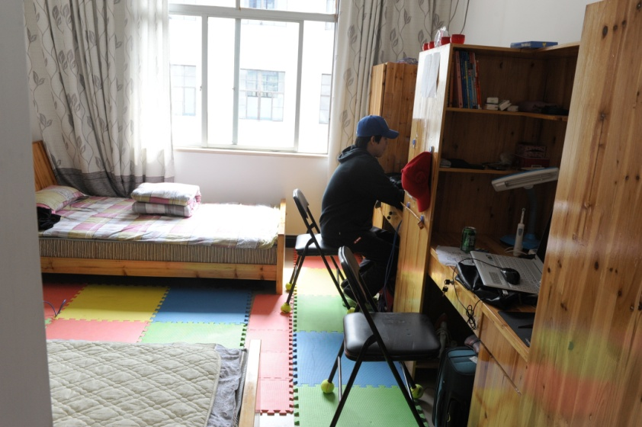

Each room has its own bathroom
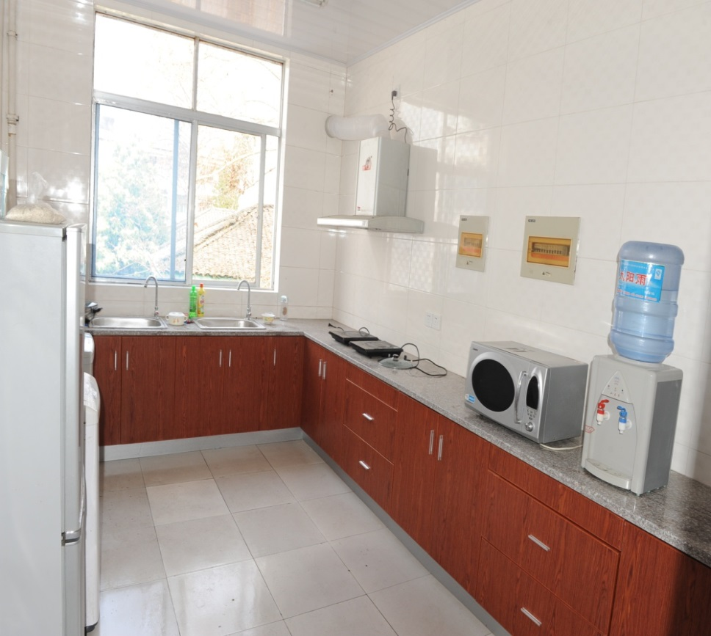
Each floor has a kitchen

Food
- Students may choose to eat in the school cafeteria, cook in the kitchen of the dorm, or eat at one of the many little restaurants near campus.
- Tunxi has a KFC and a Pizza Hut.
The Town of Tunxi
- Huangshan University is located in the town of Tunxi which has a population of about 150,000 people, now there is a express train connection directly to Beijing and Shanghai within 4 hours.
- Tunxi is a tourist town, catering to Chinese and international tourists from around the world.
- Tunxi has a well preserved ancient street lined with buildings from the Qing and Ming dynasties. Ancient Street has restaurants, bars, and outdoor cafes.
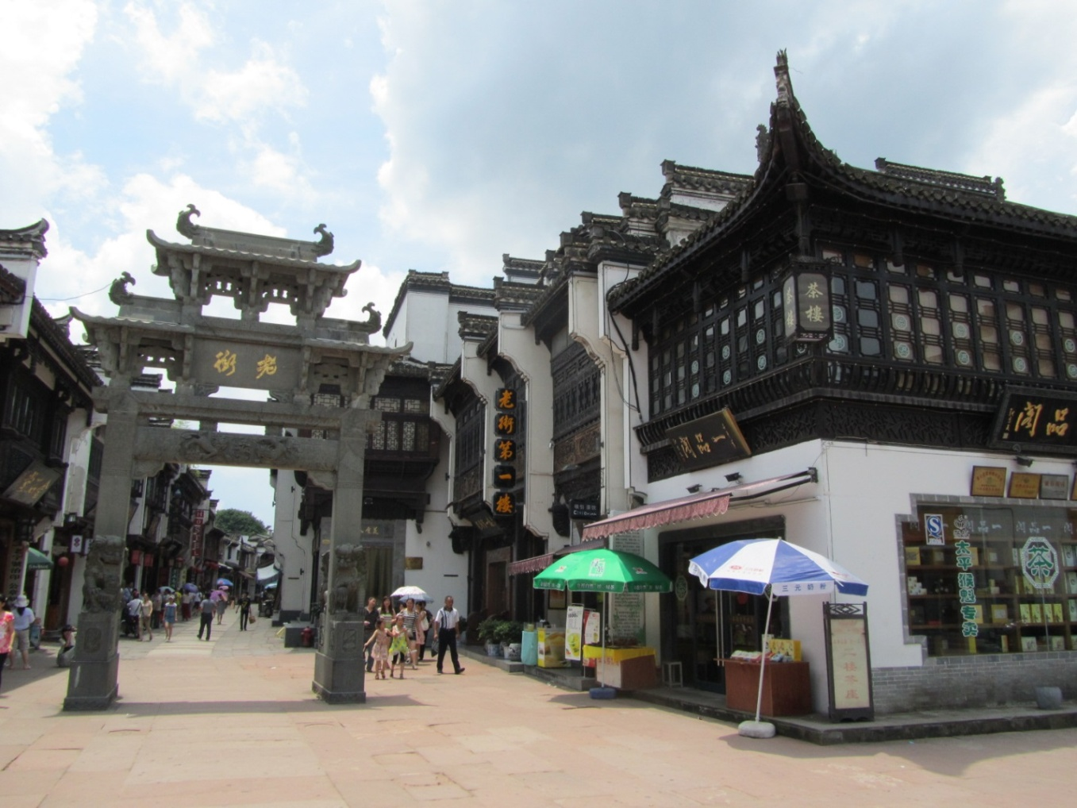
Main entrance to Ancient Street in Tunxi
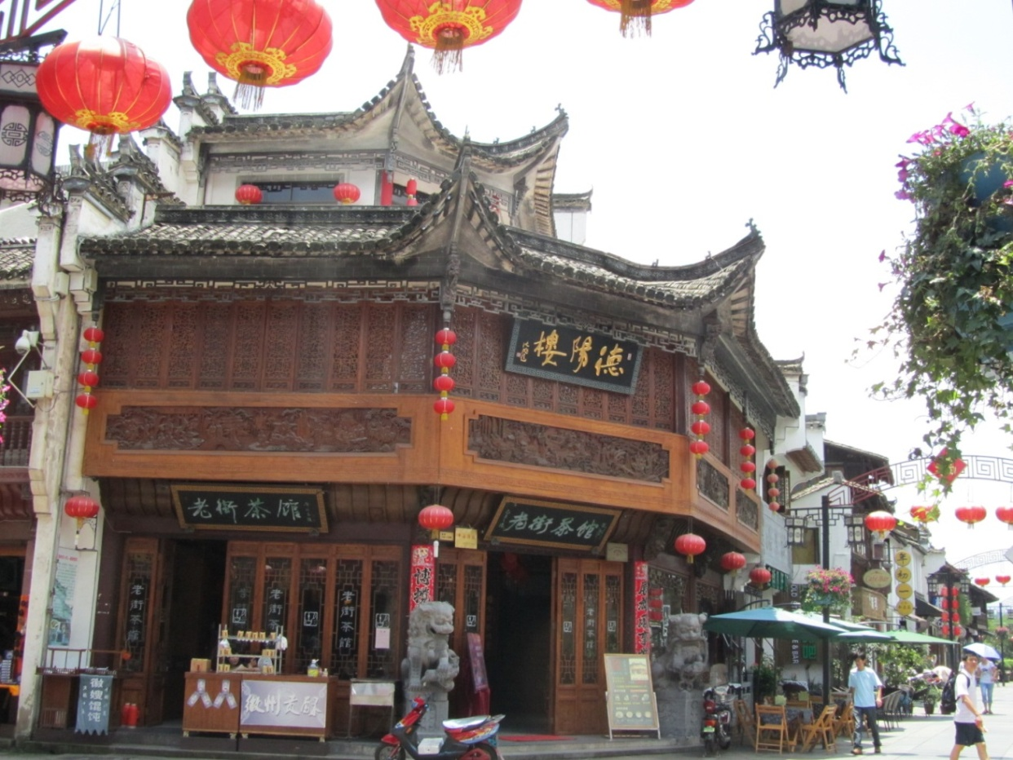
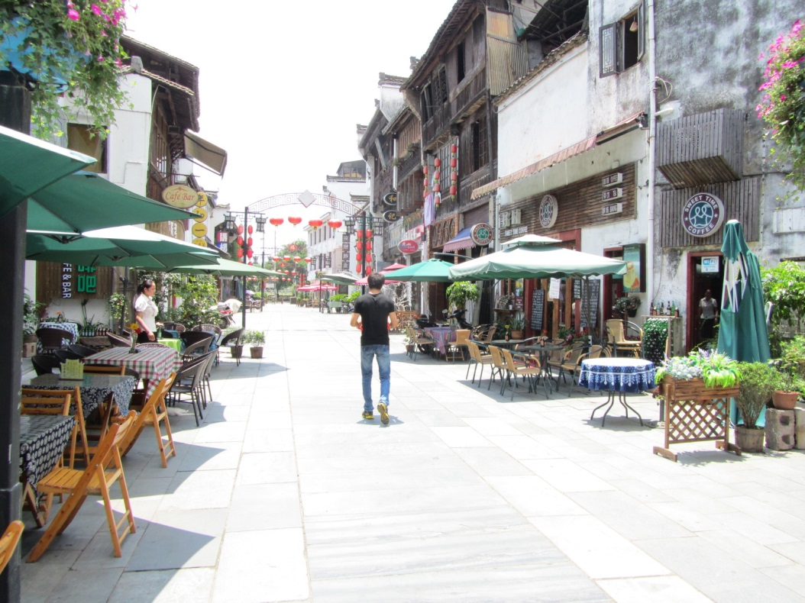
A tea house (top) and outdoor cafes (bottom) in Ancient Street
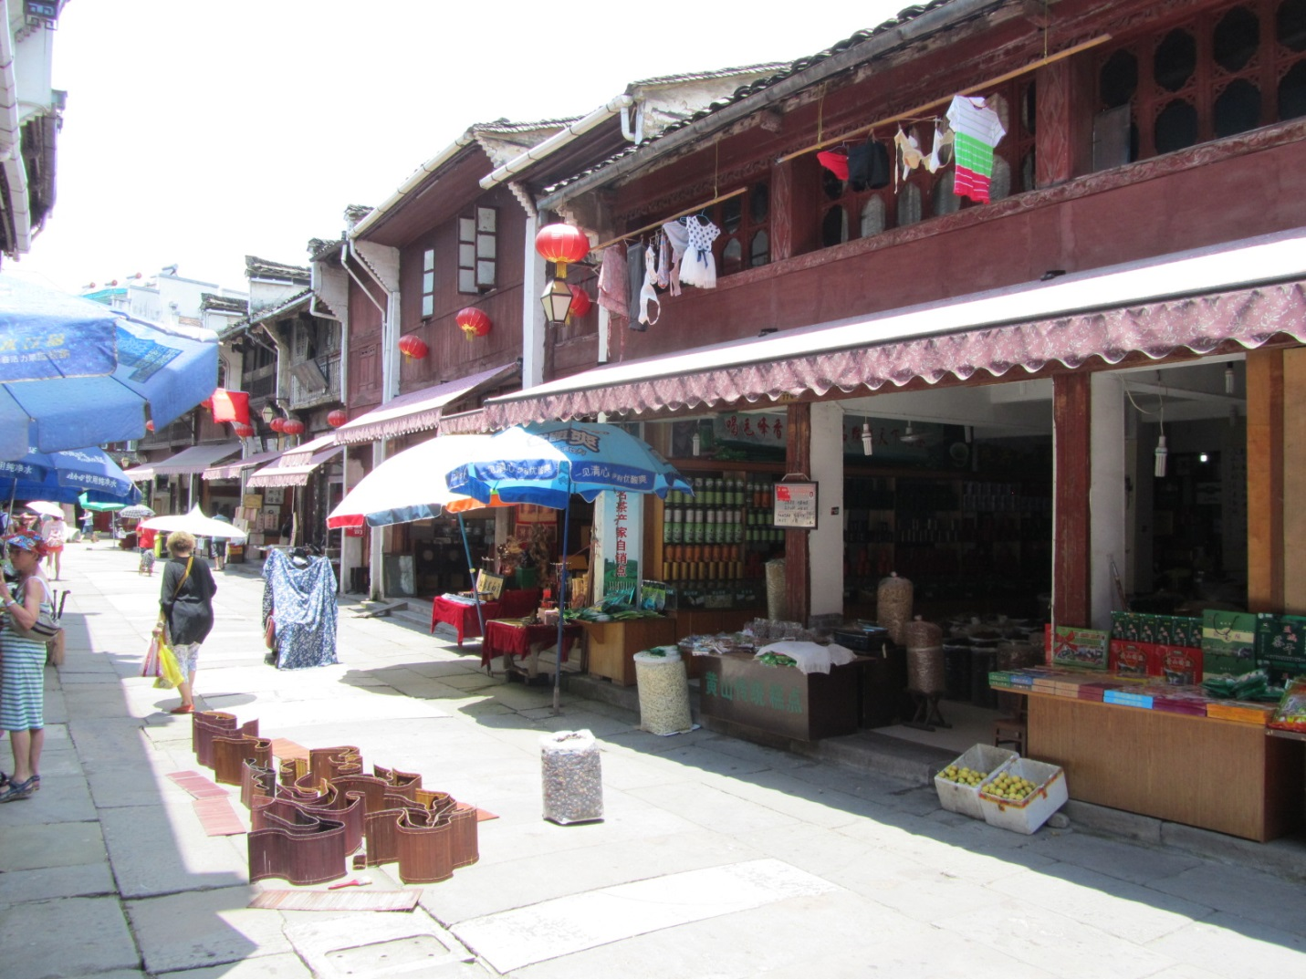
Ancient Street

Activities
- The beautiful Huangshan Mountains, a UNESCO World Heritage site, are about an hour north of town.
- Two well preserved ancient villages, Xidi and Hongcun, are less than an hour away and are also UNESCO World Heritage sites.
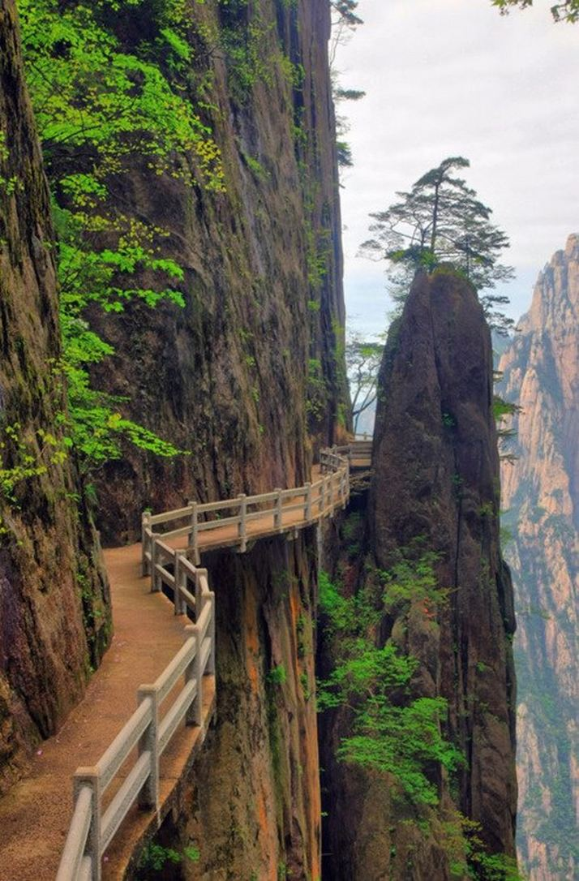
The Huangshan Mountains
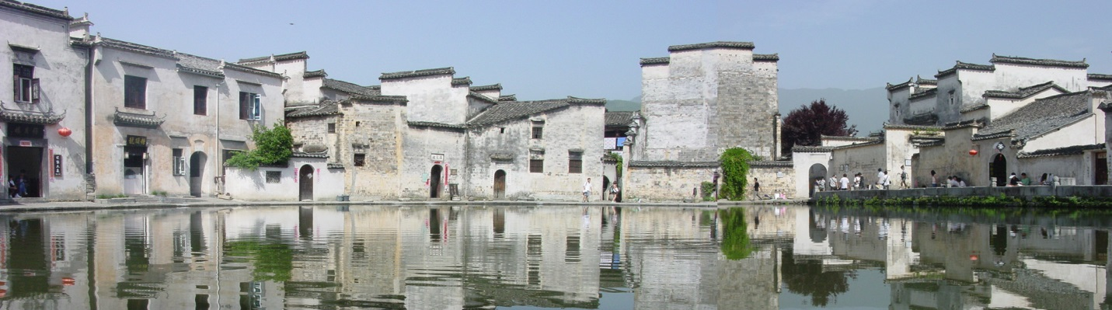
The ancient village of Hongcun with 150 residences dating back to the Ming and Qing dynasties

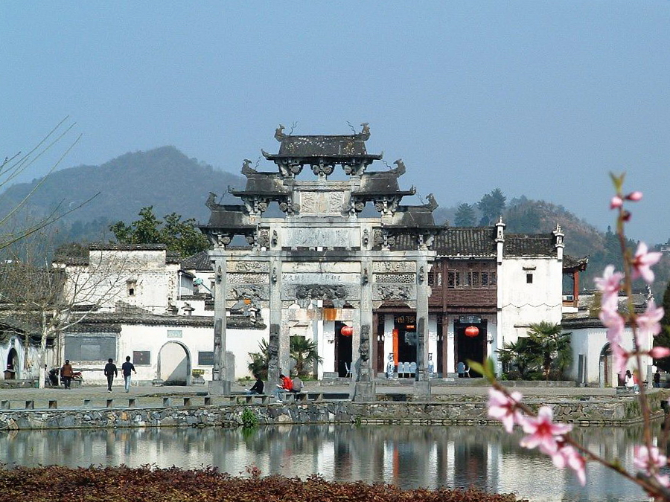
The village of Xidi with 124 well preserved residences from the Ming and Qing dynasties
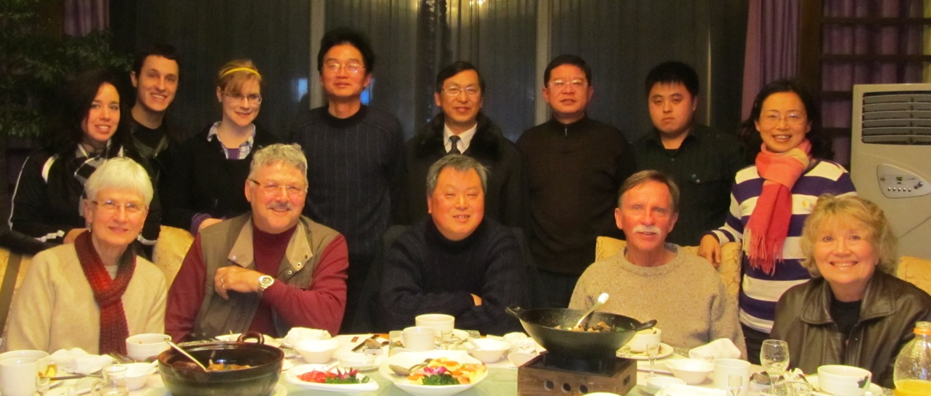
The president of Huangshan University and other school officials with the Southwestern College Semester in China group during the spring of 2012
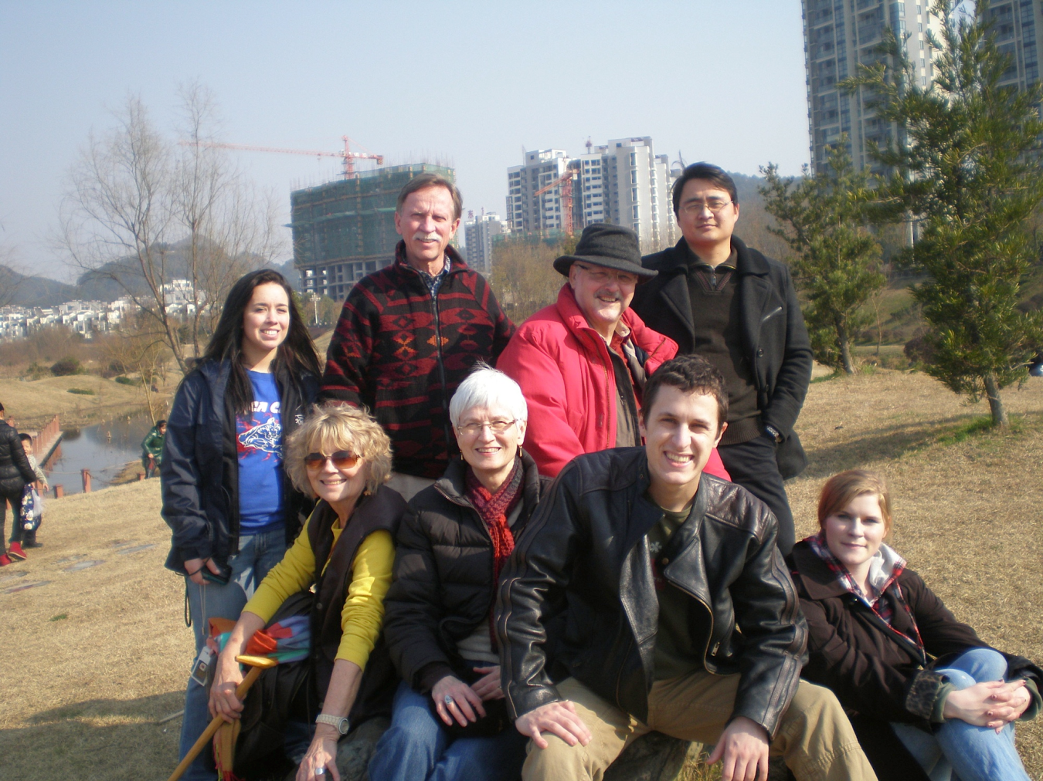
Stan Wang and the Semester in China group in a Tunxi park during the spring of 2012
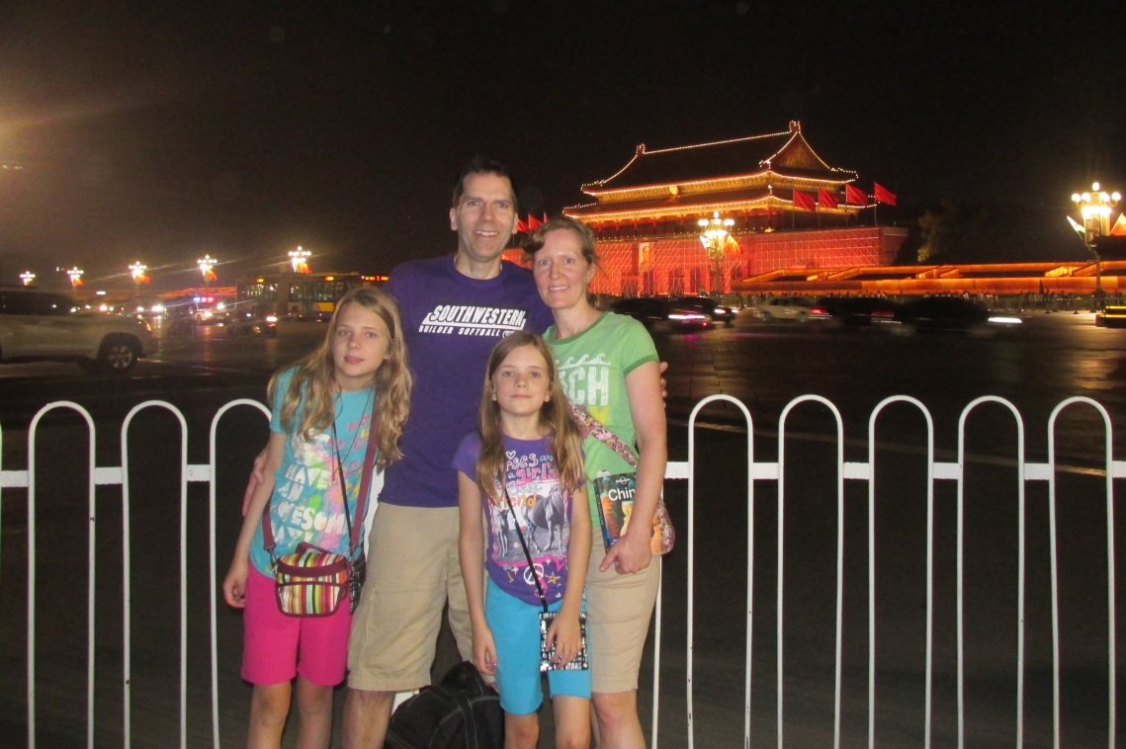
Michael and Joy Tessmer with their daughters Aideen(left) and Madeline (right) in Beijing
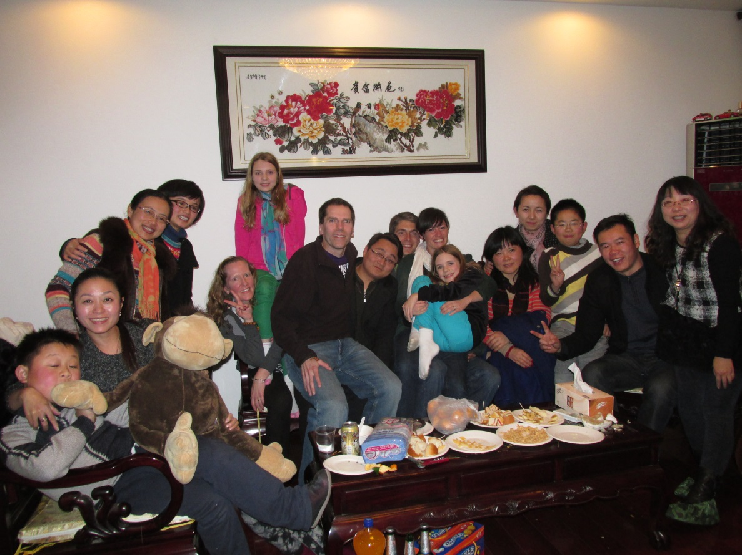
The Tessmer’s and Blackburn’s at a party in Tunxi
Semester in China, Fall 2013
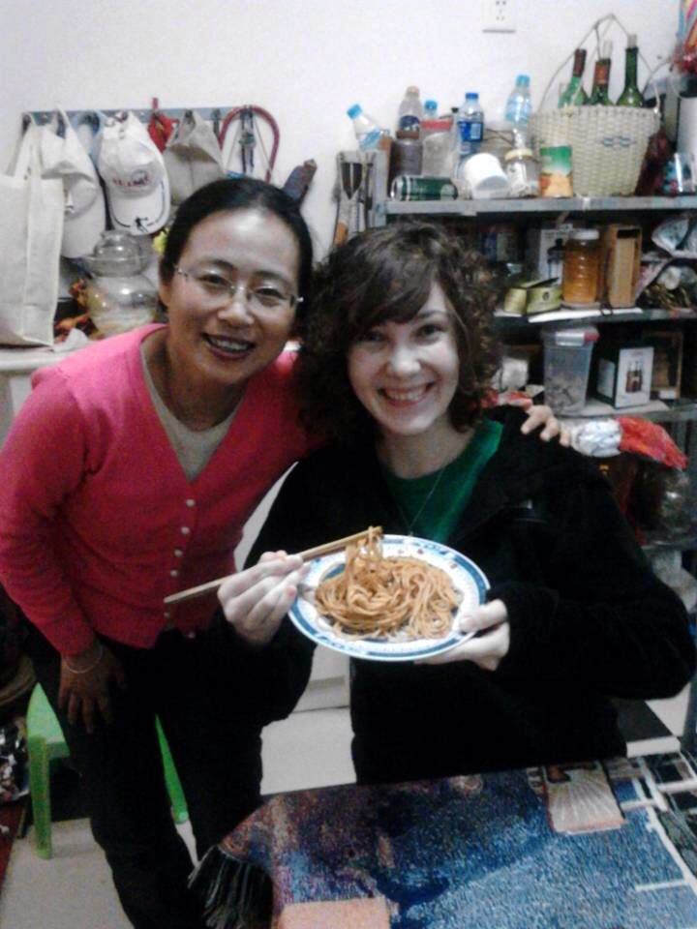
SC student, Emily Tilton, at the home of one of her host mothers, Nancy Wang
Semester in China, Spring 2014

Host Family
- Each student will have a Chinese host mother or father who speaks English.
- The host parent will acquaint the student with the town and neighborhood.
- The host parent will help the student adjust to Chinese culture.

Health Issues
- Each student will be covered by one kind of international insurance.
- The host parent will help the student acquire any needed medications.
Cost of the Program:
Each student (graduate and undergraduate) will receive a ￥2500/month ($400) scholarship from the Chinese government upon the start of the program.

Below is a detailed look at the costs.
Huangshan University tuition (In order to encourage the exchange students from sister schools, Huangshan University decided to waive the tuition charges for European and American students from sister schools since 2015.)

Huangshan University dorm room: ￥500/month( $80)
Chinese language textbooks:￥250 ($40)
Host parent: $50/month (optional)
Estimated roundtrip airfare from your city – Shanghai (estimate): $1,200.

The sum of the airfare and the Huangshan University fee is $2,000.

Below are additional costs students will have to pay out of pocket:

Train or bus from Shanghai to Tunxi (estimate): $50
Cost to get a passport: $140
Chinese visa fees: $160
Food for 10 weeks in China (estimate): $500

